

**Ethics Pledge**

**Consistent with the above statements, all homework exercises, tests and exams that are designated as individual assignments MUST contain the following signed statement before they can be accepted for grading.**

I pledge on my honor that I have not given or received any unauthorized assistance on this assignment/examination. I further pledge that I have not copied any material from a book, article, the Internet or any other source except where I have expressly cited the source.

Signature: Haodong Zhao Date: Feb 1st 2019

Please note that assignments in this class may be submitted to www.turnitin.com, a web- based anti-plagiarism system, for an evaluation of their originality.

1. a) A utility company serves 50,000 households. As part of a survey of customer attitudes, they take a simple random sample (meaning drawing at random without replacement) of 750 of these households. The average number of television sets in the sample households turns out to be 1.86 and the standard deviation is 0.80. If possible, find a 95% confidence interval for the average number of television sets in all 50,000 households. If this isn’t possible, explain why not.

Answer:

n = 750, mean = 1.86, standard deviation = 0.80

This is a large sample problem. Use equation

Consider a 95% confidence interval: 1- α = 0.95 so α = 0.05 so =

Then = 1.86 1.96 * = 1.86 0.0573

The 95% confidence interval for the average number of television sets in all 50,000 households is from 1.8027 to 1.9173.

1. Now, due to a budget constraint, the survey was conducted for only 18 households. The average number of television sets in the sample households turns out to be 1.86 and the standard deviation is 0.80. If possible, find a 95% confidence interval for the average number of television sets in all 50,000 households. If this isn’t possible, explain why not.

Answer:

It’s not possible to find a 95% confidence interval, because in this question, the sample is small, and we don’t know the sample is normal distribution. Therefore, in this question, we can’t find the confidence interval.

1. a) A cleaning business operates in the city of New York and works for the companies that lease office space in the city. The business contracts to clean office space in increments of 100 square feet. The business determines its margins by determining how long it takes a crew to clean 100 square feet of office space, and bases its rates on this information.

Because the company is relatively new, it has to estimate the time it takes to clean a 100 square feet of office space. The company estimates that it should take 5.7 hours to clean 100 square feet. The company starts its business with this expectation and works for a week straight, collecting data as it proceeds in order to be certain that it is neither over- nor under-charging its clients. The data collected by the company can be seen in the data file attached (see Canvas Assignments folder). After collecting this data, the company wants to determine if the time originally estimated to clean 100 square feet of office space was reasonable. Check this by computing a 95 percent confidence interval.

(Hint: Notice the sample size is relatively small. So, one has to justify the assumption of normal distribution, by examining (a) normal quantile plot and (b) a Goodness-of-fit test, e.g., Shapiro-Wilk test. Perform these and present the result. Once this population normality assumption is met, then use a t-value with n − 1 degrees of freedom.)

Answer:

To test the sample is normal distribution or not, we use Q-Q plot and Shapiro-Wilk test.

Q-Q plot:

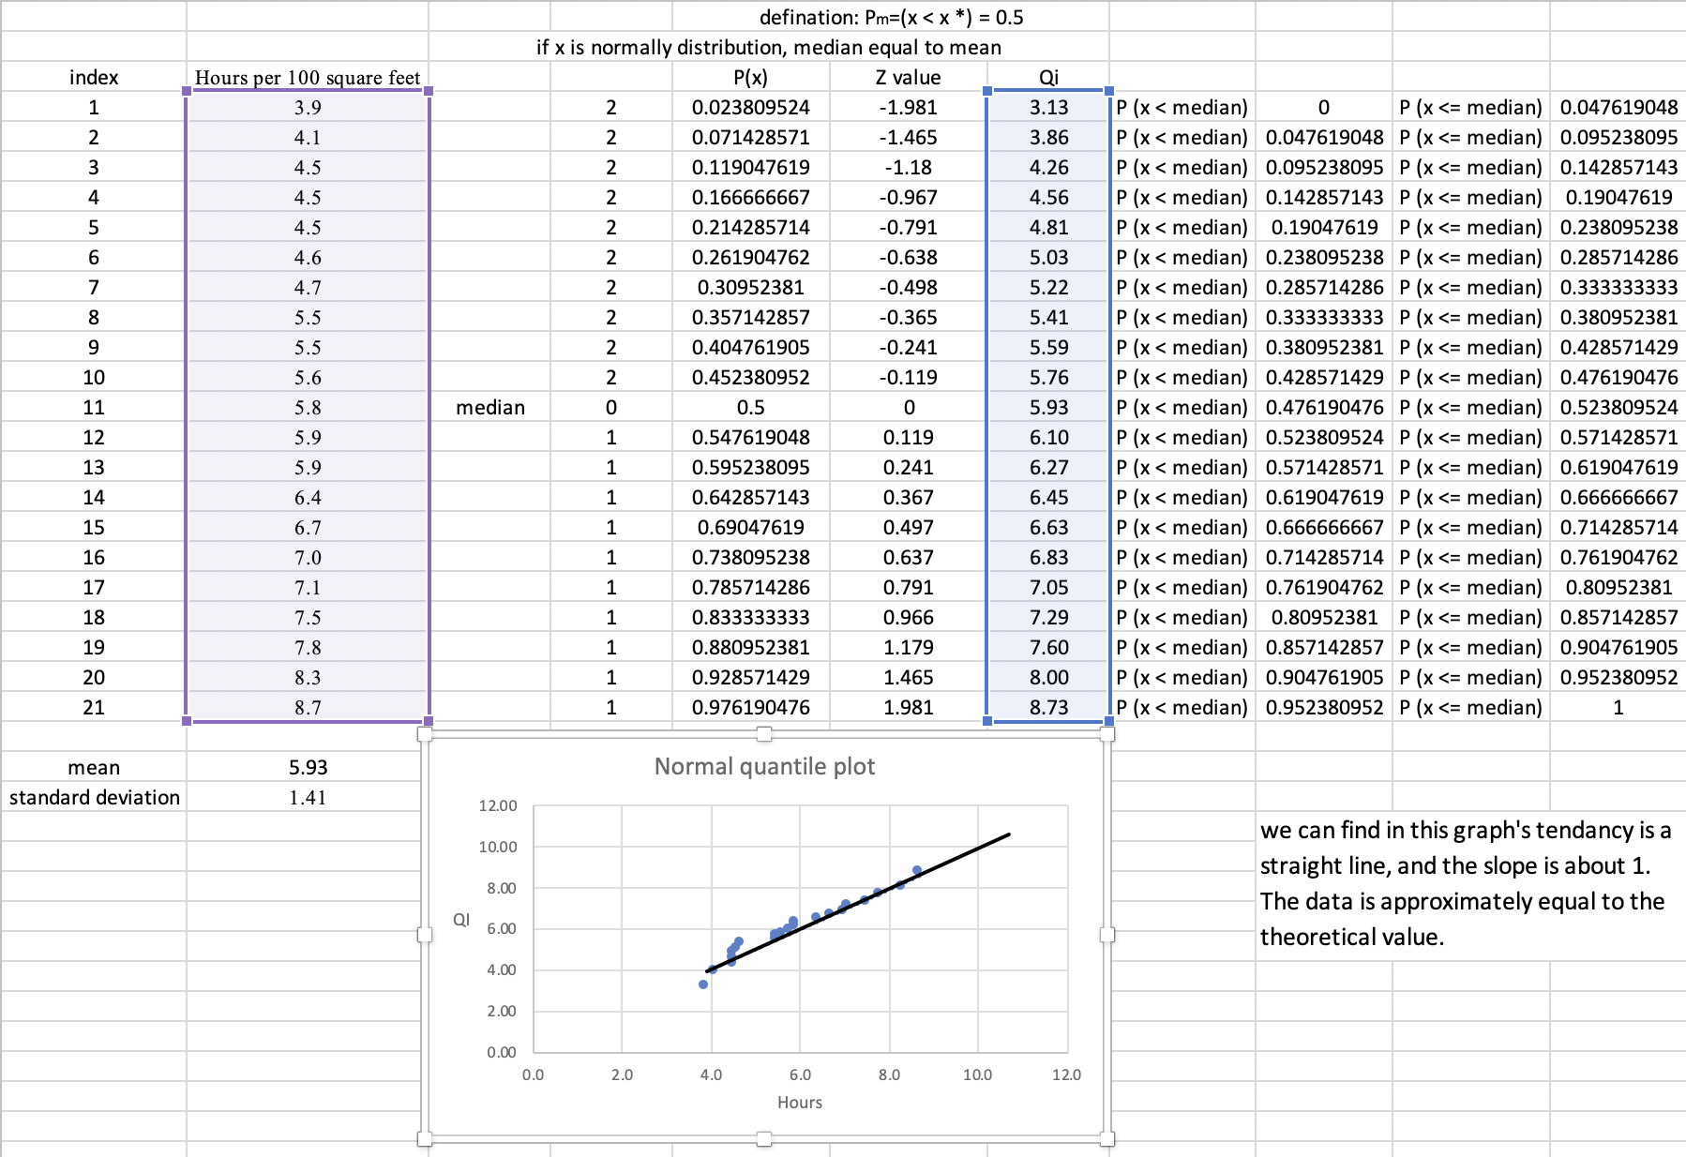

Shapiro-Wilk test:

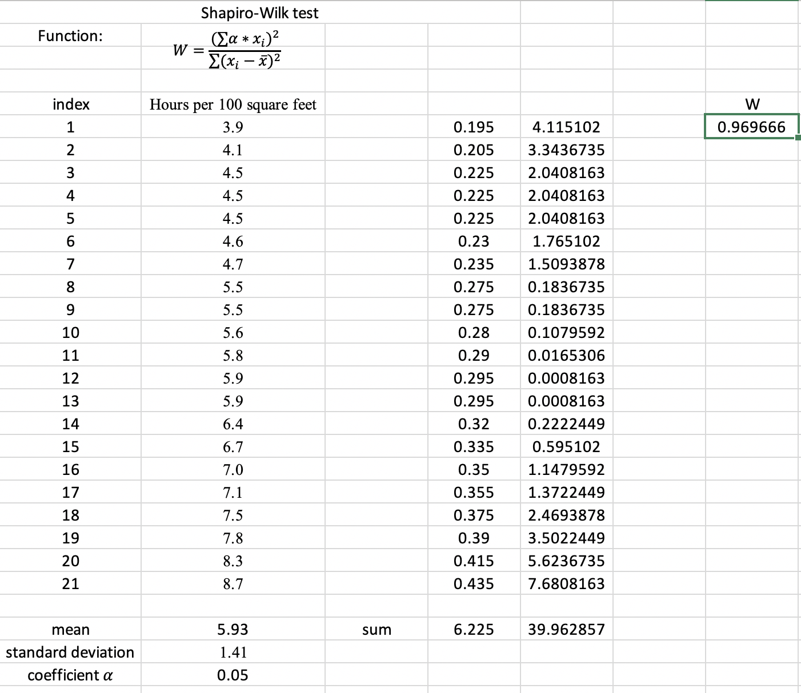

When n = 21, we can find the critical threshold from critical thresholds W𝛼 is about 0.905. And the W value we calculate is about 0.9697, the test statistic W is bigger than the critical threshold, so the assumption of a normal distribution will NOT be rejected.

From the tests, the sample is normal distribution, therefore:

n = 21, mean = 5.93, standard deviation = 1.41

This is a small sample problem. Use equation

d.f. = n – 1 = 20, consider 95% confidence interval: 1- α = 0.95 so α = 0.05

Then from the T value table, we can find = 2.086

So = 5.93 2.086 * = 5.93 0.6418

The 95% confidence interval for the average number of television sets in all 50,000 households is from 5.2882 to 6.5718, and 5.7 in this interval. Therefore, the estimate value 5.7 make sense.

1. If the cleaning company from the previous question had a sample of 8 rather than a sample of 21 upon which to base its conclusions, what would be the boundaries of the 95 percent confidence interval for the estimate of the number of hours? Assume that the sample mean and standard deviation are equal to those calculated above. Assume also the number of hours are distributed according to a normal distribution.

Answer:

n = 8, mean = 5.93, standard deviation = 1.41

This is a small sample problem. Use equation

d.f. = n – 1 = 7, consider 95% confidence interval: 1- α = 0.95 so α = 0.05

Then from the T value table, we can find = 2.365

So = 5.93 2.365 * = 5.93 1.179

The 95% confidence interval for the average number of television sets in all 50,000 households is from 4.751 to 7.109, and 5.7 in this interval. Therefore, the estimate value 5.7 still make sense.